



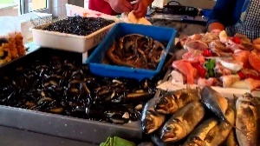
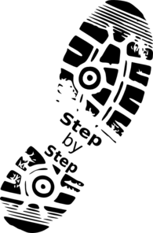
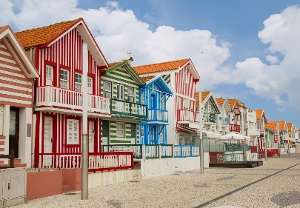
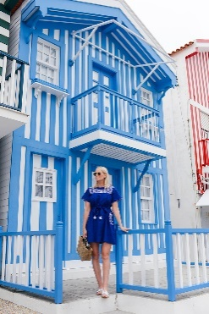
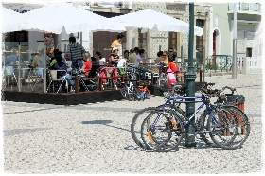
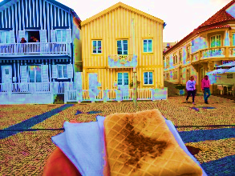

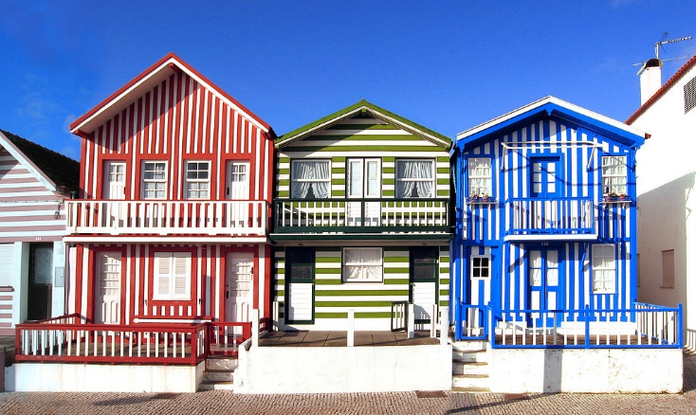





WE TAKE YOU TO COSTA NOVA
Only 20 eur / Return Ticket
Couple 35 eur – 4 pax 50 eur

BOOK NOW aveirocentral.com

Contatos:
Paulo: +351 965 380 114 We speak
Costa- Nova

Estimated Time: 2 hours

Go with a PROFISSIONAL & LOCAL GUIDE

52353/AL RNAAT: 598/2019
Visit Costa NOVA
Private Tour – to Costa Nova

